  
  Free Community
  Mobile food Pantry
  third Saturday,
  APRIL 18, 2026
  8:00 AM – 10:30 AM
  Anza Electric CoOpERATIVE
  58470 hwy-371, Anza
  CA 92539
  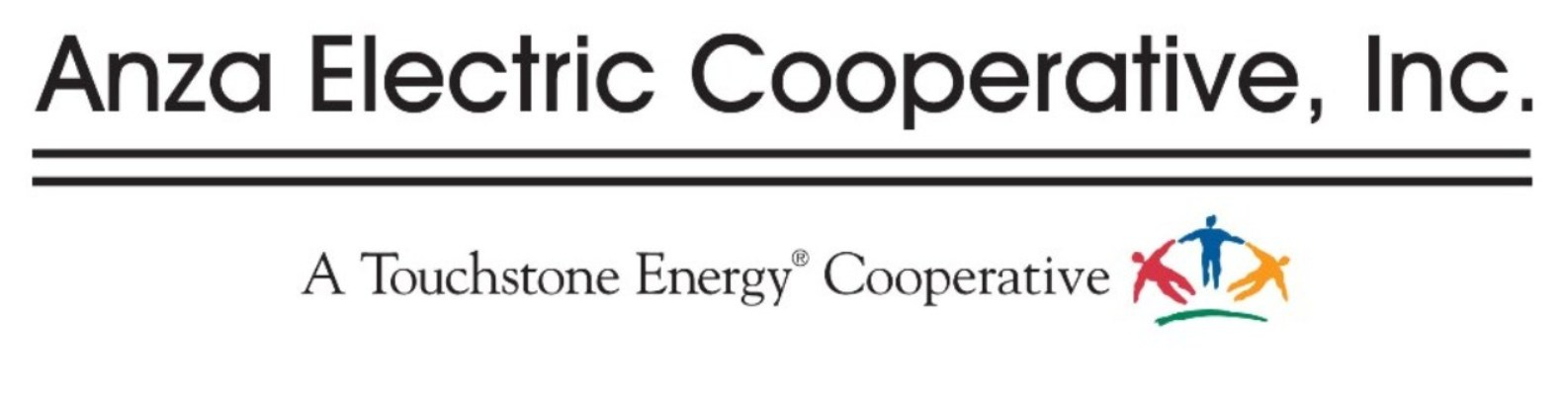
  don’t miss out! this Free Event Includes:
  Find food bank’s mobile pantry Cal-fresh aPP. aSSISTANCE
  Free community hEALTH resources
  there is a maximum of 5 families per vehicle, including the driver
  Child
  qUESTIONS CONTACT
  The Anza Electric Co-op Office
  951-763-4333
**VOLUNTEERS NEEDED** If interested call 951-763-4333 ext. 204

